2022 FORM 4 TERM 1 OPENER EXAM- (APRIL 2022)
232 / 3
PHYSICS
PAPER 3
(PRACTICAL)
TIME: 2½ HOURS
MARKING SCHEME

- i) Mass 0.057 kg ¹
Mark according to the material of metre rule in your school
v) Table 1
Position of the mass of 50g | x (cm) | y (cm)
49.5 | 13.5 | 36.0
47.5 | 12.5 | 35.0
45.5 | 10.5 | 33.7
43.5 | 10.2 | 33.2
41.5 | 9.2 | 32.3
39.5 | 8.0 | 31.5
37.5 | 7.9 | 30.6
35.5 | 5.7 | 29.8
Maximum 6 marks
NB: These values may be affected by the rule used
vi) Plotting ²
Axes¹
Scale ¹
Line¹
vii) $\frac{36-32.3}{13.5-9.2} 1=\frac{3.7}{4.3}$¹
= 0.86047¹
viii) I) y = $\frac{50}{P}x+C$
$\frac{50}{P}=slope$
$\frac{50}{P}=0.86047$
$P=\frac{50}{0.86047} =58$
(NB: P should equal or be close to the candidates mass in (i))
II) C = 25 ± 1
Centre of gravity (y-intercept)
2. a) ii) V=2.7volts
vi)
Length l(cm) | 10 | 20 | 30 | 50 | 80
Current | 0.86 | 0.48 | 0.43 | 0.255 | 0.205
p.d V(v) | 2.1 | 2.3 | 2.4 | 2.5 | 2.6
Y-V | 0.6 | 0.4 | 0.3 | 0.2 | 0.1
$$\frac{V}{Y-V}$$ | 3.5 | 5.75 | 8.0 | 12.5 | 26
$$\frac{V}{I}=R$$ | 2.442 | 4.792 | 5.581 | 9.804 | 12.683

vii) a)
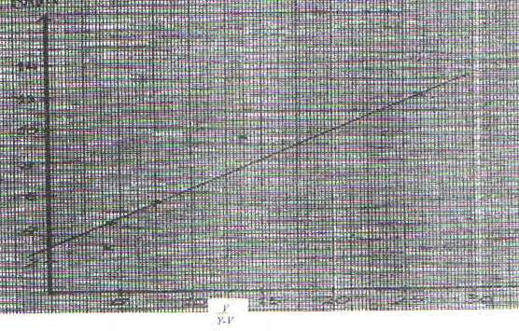
5
10
15
20
25
30
-2
4
6
8
10
12
14

$$\frac{V}{Y-v}$$

b) $Slope M=\frac{R}{∆\left(\frac{V}{Y-v}\right)}=\left(\frac{26-0}{12.6-2.6}\right) =12.751(values extracted from the graph)$
c) d=2.6Ω intercept on R axis1
$m=Gradient x51=\left(12.75x5\right)=63.75$
Part B
L₁cm | L₂ | $$\frac{L_{1}}{L_{2}}$$
30 | 50.0±2 | 0.60
60 | 27.5±2 | 2.18

$f1=\frac{L_{1}}{m+1}=\frac{30}{1.6}=18.75$
$f2={60}/{3.18}=18.75$

$\frac{f_{1}+f_{2}}{2}=\frac{18.75+18.87}{2}=18.81$

